PLACER HILLS FIRE PROTECTION DISTRICT
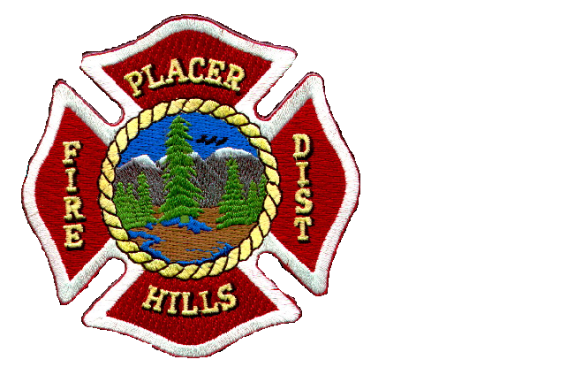17020 Placer Hills Rd. Unit 1A, PO Box 350 Meadow Vista CA 95722
530.878-0405 Fax: 530.878-0959
Fire Chief Ian Gow

Pre-Employment APPLIcation
The Placer Hills Fire Protection District is an equal opportunity employer

**Please Fully Complete the Application**
Enter Position Applying for:
Name: (First) |  | (MI) |  |  |  |  |  |  | (Last)
Mailing Address: |  |  | City: |  |  |  |  |  |  |  |  | State: |  |  | Zip:
Home Phone: |  |  |  |  |  |  |  | Cell Phone:
Email Address:
Referred By: |  |  |  |  | Date You Can Start:
Can you prove your U.S. Citizenship? (Check One) Yes No
If not a U.S. Citizen, can you provide proof of right to work in the U.S.? Yes No
Age: Are you over the age of 18? (Proof required if hired) (Check One) Yes No
Do You Have a Valid Driver’s License? Yes No | DL Number: |  |  | State: |  |  | Class: |  |  |  | List Endorsements:
Education
High School (Name, City, State):
Technical School:
Technical School:
College / University (Name, City, State):
Dates Attended: |  |  |  |  |  |  |  | Degree, Major:
College / University (Name, City, State):
Dates Attended: |  |  |  |  |  |  |  | Degree, Major:
Any Other Job Related Training:
Do You Posses a Valid EMT / CPR Card? Yes No |  |  |  |  |  | Exp. Date |  |  |  |  |  |  | Cert #

Work History (give information about your last 3 jobs, starting with the most recent)
1-Employer: |  | Dates Employed:
Address: | City: |  | State: |  | Zip:
Phone: |  | Ending Salary:
Title/Duties:
Manager's Name and Title:
Reason for Leaving:
2-Employer: |  | Dates Employed:
Address: | City: |  | State: |  | Zip:
Phone: |  | Ending Salary:
Title/Duties:
Manager's Name and Title:
Reason for Leaving:
3-Employer: |  | Dates Employed:
Address: | City: |  | State: |  | Zip:
Phone: |  | Ending Salary:
Title/Duties:
Manager's Name and Title:
Reason for Leaving:
Please Read and Sign
I hereby authorize any current or former employers to give any and all information regarding my employment and any other information, whether personal or otherwise, which may or may not be in their records. I also grant permission to the Placer Hills Fire Protection District to conduct a background investigation as they deem necessary in conjunction with my employment. I hereby release Placer Hills Fire Protection District for all liability for any damages whatsoever that may ensue from furnishing same.

I certify all information shown on this application is true and correct to the best of my knowledge. I agree to submit upon employment, to furnish such proof of age and citizenship as may be required. I understand and agree that any misstatements or omissions in material facts on any of the foregoing documents may herein subject me to disqualification or dismissal.
Signature: |  |  |  | Date:

